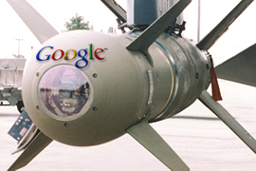 | Google Bomb – The Persian Gulf!  9/2011 Blog by founder of PersiansAreNotArabs.com

(1) What is Google Bombing?
Google bombing refers to the practice of manipulating search engines to enhance ranking for specific terms. It is done by creating and requesting a large number of back links for a specific web page. (‘backlinks’ are incoming links to a website or web page)
Google and other popular search engines, use the number of backlinks that point to a page as the importance factor of a WebPages, which eventually effects how the website is ranked.
(2) What is ‘Google Bombing – The Persian Gulf’ mean?
This refers to posting numerous links on blogs and websites using the same anchor text.
In other words linking text such as the “Persian Gulf” and/or “Arabian Gulf” to the page: http://www.PersiansAreNotArabs.com/persian-gulf/
It is an attempt to influence and enhance the ranking of a site in results returned by the Google search engine for the term the ‘Persian Gulf’.
(3) Has this attempt ever been done before?
Yes, it started with an Iranian blogger who, (after the outrage sparked in the global Iranian community) invited other bloggers to link to his simple and clever page called: Arabian-Gulf.info which appeared as a standard 404 ‘Not Found error page’ informing you that ‘The Arabian Gulf Does Not Exist!’
Within days of the initial suggestion for the Google Bomb, if a person was to type the phrase ‘Arabian Gulf’ in Google, the first result had become the site www.Arabian-Gulf.info
(4) Why start another campaign?
The controversy of the Persian Gulf being called the Arabian Gulf has been the subject of public attention for several years. During this time, several websites owned by non-Iranians have used a similar technique and have outranked our friends site Arabian-Gulf.info

(5) What now?
The site PersiansAreNotArabs.com established in year 2007 has outranked many sites for popular keywords and ranks #1 for many.
Our Google Webmaster Tools page shows over 60,500 links to our home page “http://www.persiansarenotarabs.com” as shown below:
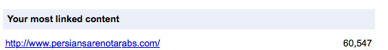
In other words this site among other sites has the highest potential to outrank other non-Iranian competitors in ranking for the popular phrase the ‘Persian Gulf’!
As of now, the site currently ranks on page 2 of Google among 12,400,000 results. (You may validate this by simply doing a quick Google Search)
Our goal in this campaign is to rank #1 for the term: “Persian Gulf”

We’ve done 80% of the job and are
asking for your help to go the other 20.

Help to save historical name of Persian Gulf
- We eagerly ask you to simply post the link:
http://www.PersiansAreNotArabs.com/persian-gulf
on your Facebook, Twitter and other social network accounts and also encourage your friends and family to do the same.

- Please link to our pages on different blogs and websites to help spread the word and also support us in our campaign.

In union there is strength.
Let’s work as a team!
Together Everyone Achieves More

